This week, the Math Department brings us…

**Serge Lang Undergraduate Lecture**

Thursday, September 22, 2016

60 Evans, 4pm

The annual Serge Lang Lecture will be held this coming Thursday! This year's talk, titled *The Mathematics of Doodling*, will be given by **Professor Ravi Vakil of** Stanford University. Join us at **3pm** **in** **1015 Evans** for **tea and pie** with the speaker. The talk starts after the tea at **4pm** **in** **60 Evans.** After the talk, come for the **Serge Lang Dinner** at **5:10pm back in 1015 Evans,**which will be attended by the speaker as well as students and professors. The tea, pie, and talk will all be **free**; tickets to the dinner can be purchased for $12 at 938 Evans or $15 at the door.



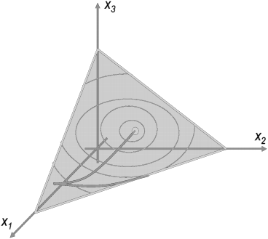

**Monday, September 26 from 5 to 6pm in 740 Evans**

**Speaker**: Christopher Eur

**Title**: *The Global Attractor Conjecture.*

**Abstract**: The Global Attractor Conjecture (GAC) is a fundamental conjecture in chemical reaction network theory (CRNT) that has eluded proofs for decades despite appearing intuitively obvious. In this talk, we introduce CRNT following works of Jackson, Horn, and Feinberg, and discuss its ties to algebraic geometry and convex geometry. We conclude with a sketch of the proof of GAC recently proposed by Gheorghe Craciun.

**Recommended prerequisites**: Math 53, 54, 55.

The Berkeley mini Math Tournament is a middle school math competition held on campus, written, directed and put on by UC Berkeley students. Come to BmMT’s Problem Writing Session on **Wednesday, September 21 at 6pm in 740 Evans** to learn how to write the math problems used in the competition. We will be setting up a problem submission system with git, so bring your laptop! Dinner is provided.

**Math Monday Series**

**BmMT Problem Writing Session**